|  |  |
| --- | --- |
| Grid computing | Cloud Computing |
| It is for Application oriented | It is for Service Oriented |
| It operates with in a corporate network | It can also be accessed through the internet |
| User management: Decentralized management | User management: Centralized management |
| Accessibility : Through Grid middleware | Accessibility : Through standard web protocols |
| Scalability : normal | Scalability : high |
| Architecture : Distributed | Architecture : Client server |
| Computation : Maximum | Computation : On Demand |
| Virtualization : Data and Computing resources | Virtualization : Hardware and software platforms |

**Grid computing vs Cloud Computing**

The **main difference** between grid and cloud computing is that the **grid computing refers to a collection of computer resources located at different locations to process a single task while the cloud computing refers to manipulating, configuring and accessing hardware and software resources remotely over the internet.**

**Virtualization**

**Virtualization : Virtualization in Cloud Computing is making a virtual platform of server operating system and**[storage](https://data-flair.training/blogs/cloud-storage-tutorial/)**devices. This will help the user by providing multiple machines at the same time it also allows sharing a single physical instance of resource or an application to multiple users.**

**Virtualization types:**

* Operating System Virtualization
* Hardware Virtualization
* Server Virtualization
* Storage Virtualization

**Advantages Virtualization :**

* **Security**
* **Less Expensive**
* **Maximum Hardware resources utilization**
* **Maximum throughput**

**Virtualization softwares: vmware ESX ,** Microsoft's Hyper-V. etc ..

**Virtualization methods: Full virtualization and Para virtualization**

**Full virtualization : Para virtualization:**

The **main difference** between full virtualization and Para virtualization in Cloud is that **full virtualization allows multiple**[**guest operating systems**](https://pediaa.com/what-is-the-difference-between-host-and-guest-operating-system/#Guest%20Operating%20System)**to execute on a host operating system independently while Para virtualization allows multiple guest operating systems to run on host operating systems while communicating with the**[**hypervisor**](https://pediaa.com/what-is-the-difference-between-type-1-and-type-2-hypervisor/)**to improve performance.**

|  |  |
| --- | --- |
| **Full Virtualization is less secure.** | **While the Paravirtualization is more secure than the Full Virtualization.** |
| **Full Virtualization is slow than paravirtualization in operation.** | **Paravirtualization is faster in operation as compared to full virtualization.** |
| **It provides the best isolation.** | **It provides less isolation compared to full virtualization.** |

**Cloud services :**

**SaaS (Software-as-a-Service)** – Provides access to the software applications as a service to the end users.

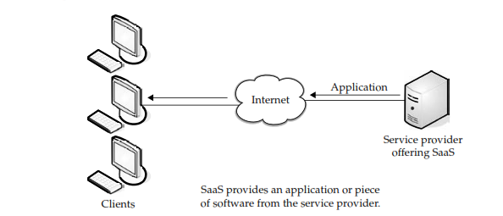

Examples of software applications :

Customer resource management (CRM)

Video Conferencing

IT Service Management

Accounting

Web analytics

Web Content management

Advantages of SaaS:

Smaller staff

Better marketing

Security

More bandwidth

Customer support 24*7

Customization

**PaaS (Platform-as-a-Service)**– Provides the runtime environment for applications, development and deployment tools.

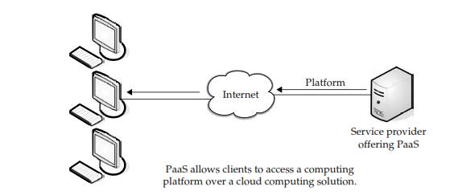

Examples of PaaS :

* AWS Lambda. ...
* Google App Engine. ...

**HaaS (Hardware-as-a-Service)** – Provides resources such as virtual machines, virtual storage, etc.

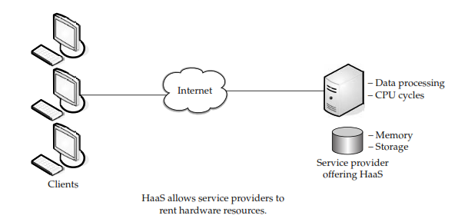

**Haas provide services**

**server space**

**network equipment,**

**Internet connectivity**

**memory,**

**CPU cycles**

**storage space etc..**